# CLASS : T. E. (E &TC) SUBJECT : DC

**EXPT. NO. : 9 DATE:**

# Roll NO. :32457

**TITLE : Generation and reception of FSK in presence of noise PREREQUISITES**

**FOR EXPT.** : 1. Different Line coding techniques

1. Concept of ASK (amplitude shift keying)
2. Concept of matched filter

**OBJECTIVE :** 1. To study the blocks in BFSK transmitter and receiver.

1. To study the power spectrum of BFSK briefly.
2. To understand difference between coherent and non coherent BFSK reception technique.

# APPARATUS :

| Sr.  No. | Apparatus | Range |
| --- | --- | --- |
| 1. | FSK MOD /DEMOD kit | |
| 2. | DSO | Dual Channel, 60 MHz |

**THEORY :**

* In binary frequency shift keying (BFSK), the frequency of a sinusoidal carrier is shifted between two discreet values.
* One of these frequencies (fH) and represents a binary “1” and other

value (fL) represents a binary “0”.

* The representation of digital data using FSK is as shown in fig.1.Note

that there’s no change in the amplitude and phase of the carrier.

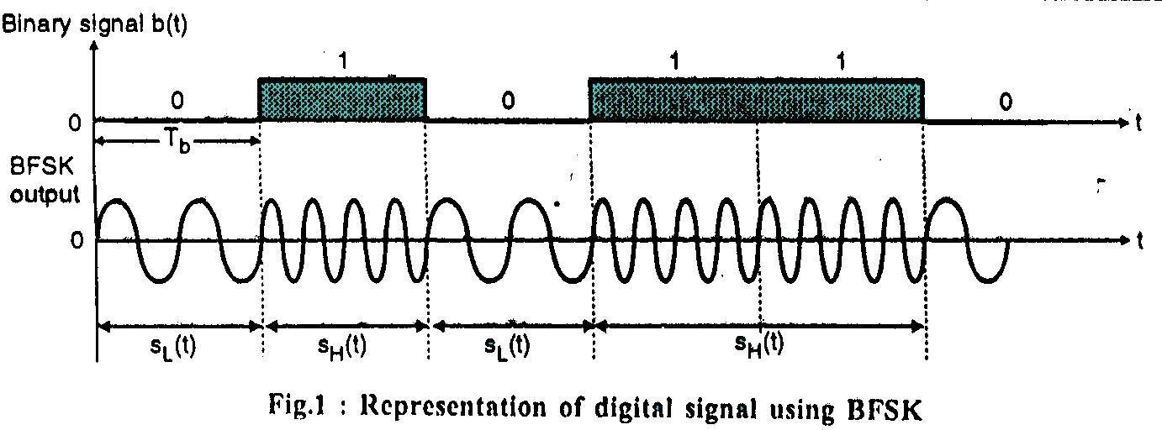

* In BFSK the binary data waveform d (t) is used to generate a binary signal,

VBFSK(t)=√2Ps cos[ωct+d(t)Ωt] 1

Where d (t)=±1 corresponding to the logic levels 1 and 0 at the input respectively.

* The transmitted BFSK signal is of constant amplitude √2Ps and is given by

sH(t)=vBFSK(t)= √2Ps cos[ωc+Ω]t …….….for logic “1” level input

sL(t)=vBFSK(t)= √2Ps cos[ωc-Ω]t …….….for logic “0” level input

If we call (ωc+Ω)= ωH and (ωc-Ω)= ωL then the above equations will be modified as

sH(t)= √2Ps cos ωHt 2

and sL(t)= √2Ps cos ωLt 3

* As already mentioned, Ps=Eb/Tb

therefore, sH(t)= √(2 Eb/Tb)cos ωHt 4

and sL(t)= √(2 Eb/Tb)cos ωLt 5

# Generation of BFSK:

* The block diagram of BFSK generator is shown in fig 2. It consists of two oscillators, which produce carriers at frequencies fH and fL respectively.

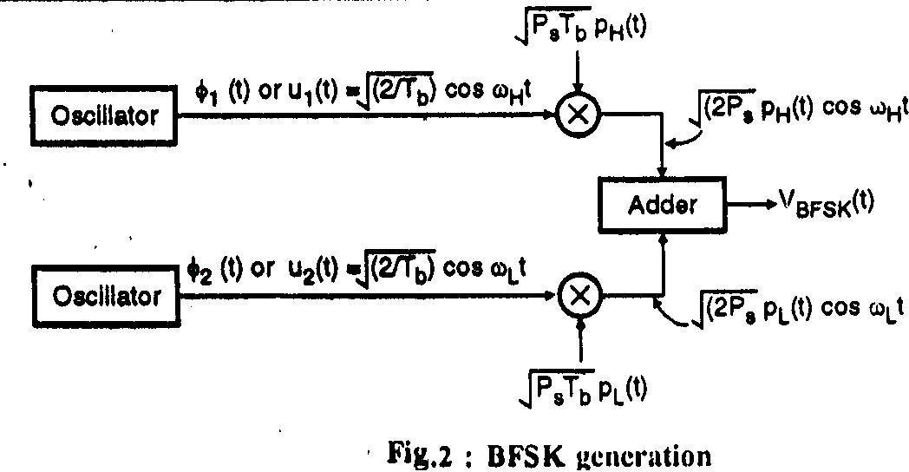

* The oscillator outputs are applied to the inputs of the multipliers (balance modulator). The other input to the two multipliers are the signals pH(t) and pL(t).
* These signals are derived from the data bits d (t) as follows:

| Data bit to be transmitted | Value of d(t) | pH(t) | pL(t) |
| --- | --- | --- | --- |
| Binary 0 | -1V | 0 | 1 |
| Binary 1 | +1V | 1 | 0 |

* The other inputs to the two multipliers are the reference signals u1 (t) or

φ1 (t) and u2 (t) or φ2 (t) which are generated by two oscillators u1(t)=φ1(t)= √(2/Tb)cos ωHt 6

u2(t)=φ2(t)= √(2/Tb)cos ωLt 7

* The multiplier outputs are then added to get the BFSK signal, given by equation 1
* Thus when binary 0 is to be transmitted, pL (t)=1 and pH (t)=0 and for a

binary “1” to be transmitted pH (t)=1 and pL (t)=0.

* Hence the transmitted frequency will have a frequency either fH or fL.

# Spectrum of BFSK:

1. The BFSK output in terms of the variables pH (t) and pL (t) is given by,

VBFSK (t)=√2Ps pH cos[ωHt+θH] +√2Ps pL cos[ωLt+θL]… 8

1. Each term in equation 8 looks like the signal √2Ps b (t) cosωCt which we have used in BPSK. The difference is that in BPSK, the signal b (t) is bipolar which alternates between +1 and -1. In BFSK the two signals pH (t) and pL (t) are alternating between 0 and +1 only.
2. So now let us write pH and pL in the form of sums of a constant and a bipolar variable as follows:

pH (t)= ½ + ½ p’H(t)… 9

pL (t)= ½ + ½ p’L(t)… 10

where p’H(t) and p’L(t) are bipolar variables, which alternate between

+1 and -1. Also they are complementary signals i.e when p’H=1, p’L=-1 and vice versa.

1. Substituting the values of pH (t) and pL (t) from equations 9 and 10 into the expression for BFSK equation 8 we get,

vBFSK (t)= √Ps/2 cos[ ωH(t) +θH] + √Ps/2 cos[ ωL(t) +θL] +

√Ps/2ω’H cos[ωH(t) +θH]+√Ps/2ω’L cos[ωH(t) +θH] 11

This expression will help us draw the spectrum of BFSK.

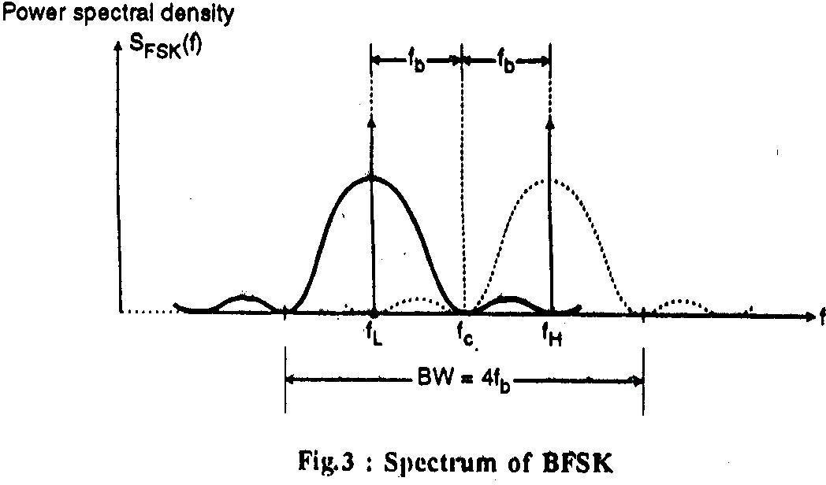

1. The first term in the expression 11 will produce a power spectral density, which consists of an impulse at fH.
   * Similarly the second term produces a power spectral density which consists of an impulse at fL
   * The third and fourth terms in the equation 11 together will produce the spectrum of a BPSK.
   * The individual power spectral density patterns of the last two terms in equation 11 are shown in fig 3.
   * Note that these patterns have been drawn with an assumption that fH - fL= 2fb
   * With this separation, the bandwidth of BFSK is,

BW(BFSK)= 4fb

Note that this bandwidth is twice the bandwidth of BPSK.

# BFSK Reciever(coherent receiver):

* The BFSK receiver block diagram is as shown in fig 4. It is supposed to regenerate the original digital data form the BFSK signal at its input.
* The received BFSK signal is denoted by x (t). It is applied to two correlators.
* These correlators are supplied with locally generated coherent reference signals Ф1 (or u1) and Ф2(or u2).

Ф1(t) or u1(t)= √(2/Tb)cos ωHt 12

U2(t)=φ2(t)= √(2/Tb)cos ωLt 13

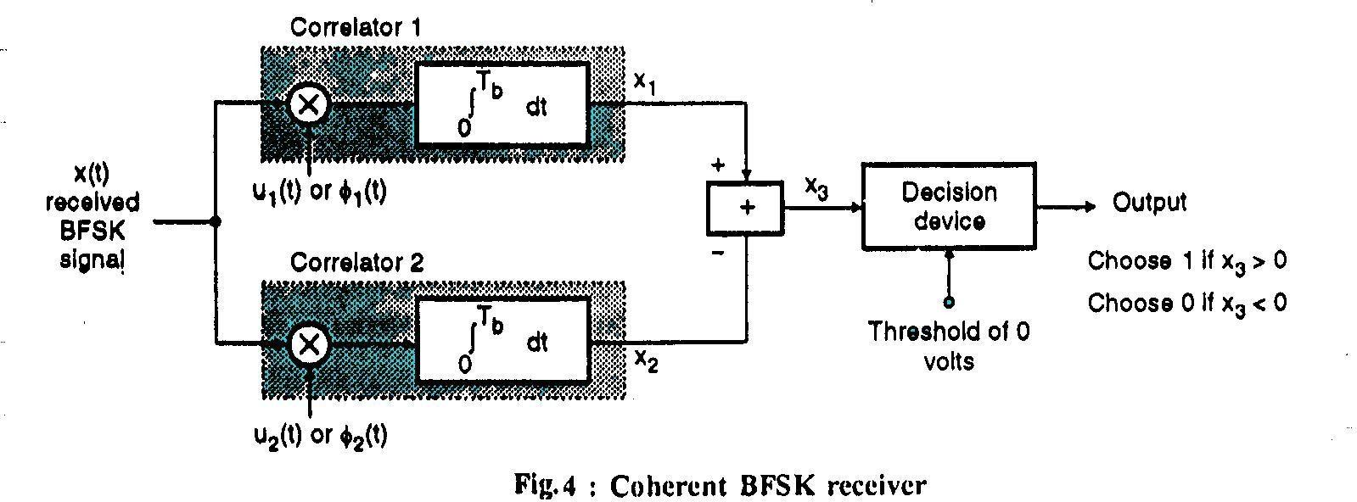

* The outputs of the two correlators are then subtracted to get a signal x3 such that,

x3=x1-x2

* The signal x3 is then applied to a decision device which compares it with a threshold level of zero volts.
* If x3>0,then the receiver decides that a 1 was transmitted whearas if x3<0 then a decision is made in favour of a zero.

# Non coherent Binary Modulation Techniques :

* Till now we have discussed the coherent modulation techniques in which the phase synchronous locally generated carrier was used for the purpose of detection.
* But practically sometimes it is not possible to have the knowledge of the carrier phase.
* Then we have to use the coherent binary systems.
* In this section we will consider the non coherent FSK system and the differential PSK or DPSK systems.

# Non coherent BPSK :

* + In the binary FSK system, we know that the transmitted signal can be either sH (t) and sL(t) are given by,

sH(t)= √(2 Eb/Tb)cos (2∏fHt) 14

sL(t)= √(2 Eb/Tb)cos (2∏fLt) 15

* + The transmission frequency fH represents a logic 1 and fL represents a logic 0.
  + The non coherent receiver of BPSK is shown in fig 5.
  + A pair of matched filters alongwith envelope detectors is being used.
  + The matched filter in the upper path is matched to √(2/Tb) cos(2∏fLt) whereas the filter in the lower path is matched to √(2/Tb)cos (2∏fHt).

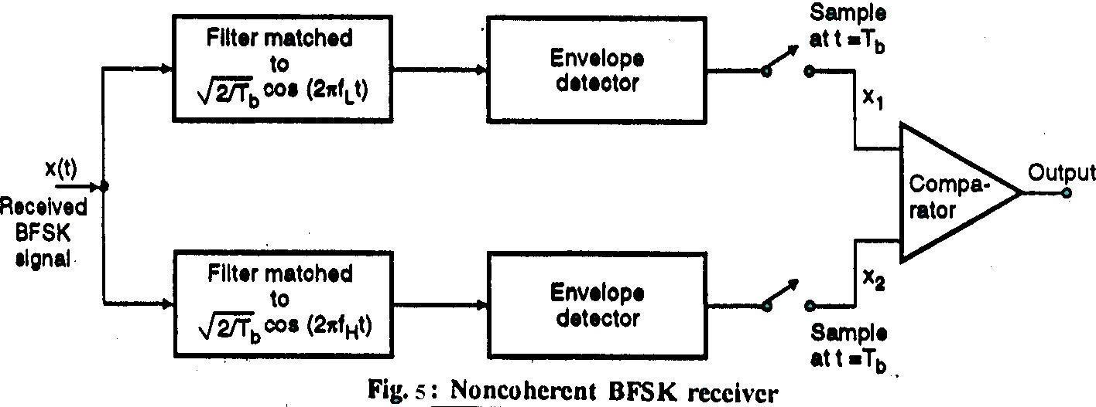

* + The outputs of the envelope detector are sampled at t= Tb and a comparator is used for comparing their values x1 and x2.
  + If x1>x2 then the receiver decides that a logic 1 was transmitted

whereas with x1<x2 the receiver’s decision is in favour of a 0.

* + The error probability of non coherent BFSK is Pe=1/2 e-(Eb/2N0) 16

# PRACTICAL BLOCK DIAGRAM OF FSK MODULATION/DEMODULATION :

FSK MODULATOR

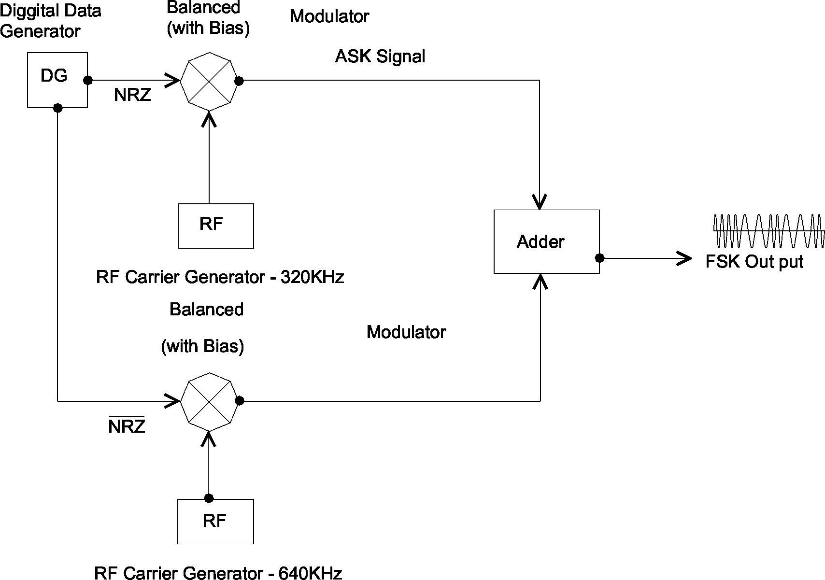

FSK DEMODULATOR (RESONANT PHASE SHIFT DETECTOR)

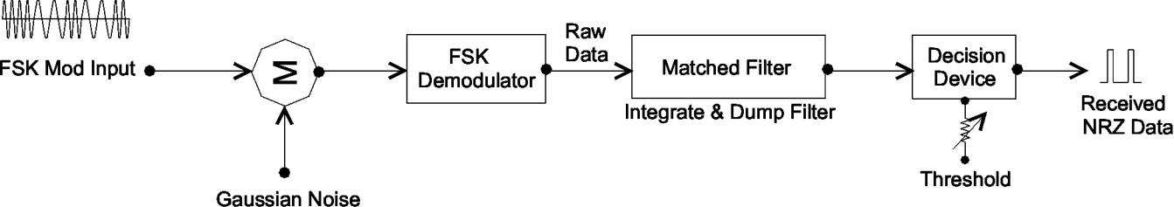

# PROCEDURE:

To generate FSK signal and demodulate it by PLL detector: -

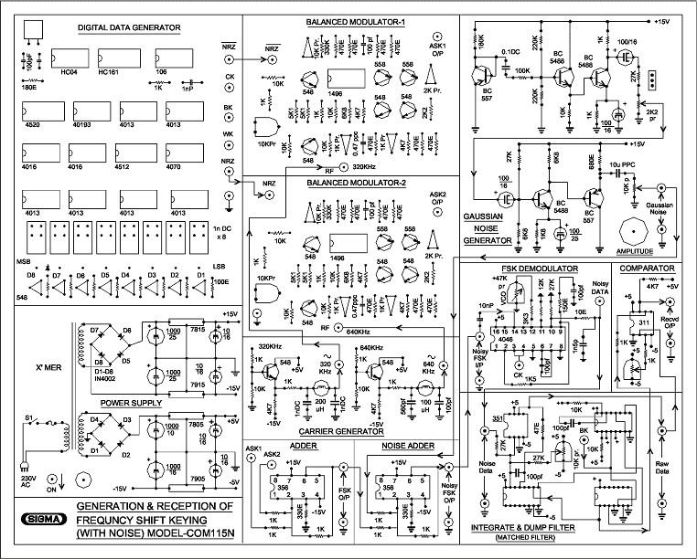

1. Connect DSO channel 1 at carrier clock (Ck) socket and observe it

….(waveform T1).

1. Connect DSO channel 1 at bit clock(Bk) socket and observe it

….(waveform T2).

1. Connect DSO channel 1 at word clock(Wk) socket and observe it

……(waveform T3).

1. Connect DSO channel 1 at NRZ DATA(NRZ) socket and observe it

……..(waveform T4).

1. Connect DSO channel 1 at NRZ* DATA(NRZ’ socket and observe it

…(waveform T5).

1. Connect DSO channel 1 at RF carrier socket (in carrier generation section) for frequency 320kHz and 640kHz. Observe the waveforms on DSO for these two frequencies.
2. Connect DSO channel 1 at NRZ DATA (NRZ) socket.
3. Connect DSO channel 2 at the output of balanced modulator-1. Observe ASK output and draw its spectrum.
4. Same as, connect DSO channel 2 at the output of balanced modulator-2. Observe ASK output draw its spectrum.
5. Apply both output of balanced modulator 1 and balanced modulator 2 to adder section. Connect DSO channel 2 at output of the adder. Observe FSK output draw its spectrum.
6. Connect DSO channel 1 at Gaussian noise output and observe it. Keep noise level at minimum.
7. Observe received raw data signal at the output of FSK demodulator.
8. Observe received pure NRZ data at the output of data squarer.
9. Now add Gaussian noise by rotating noise level pot and observe its effect on all received signals.

# OBSERVATIONS AND GRAPHS:

Observe and Plot the observed FSK modulator and demodulator waveform for given data input.

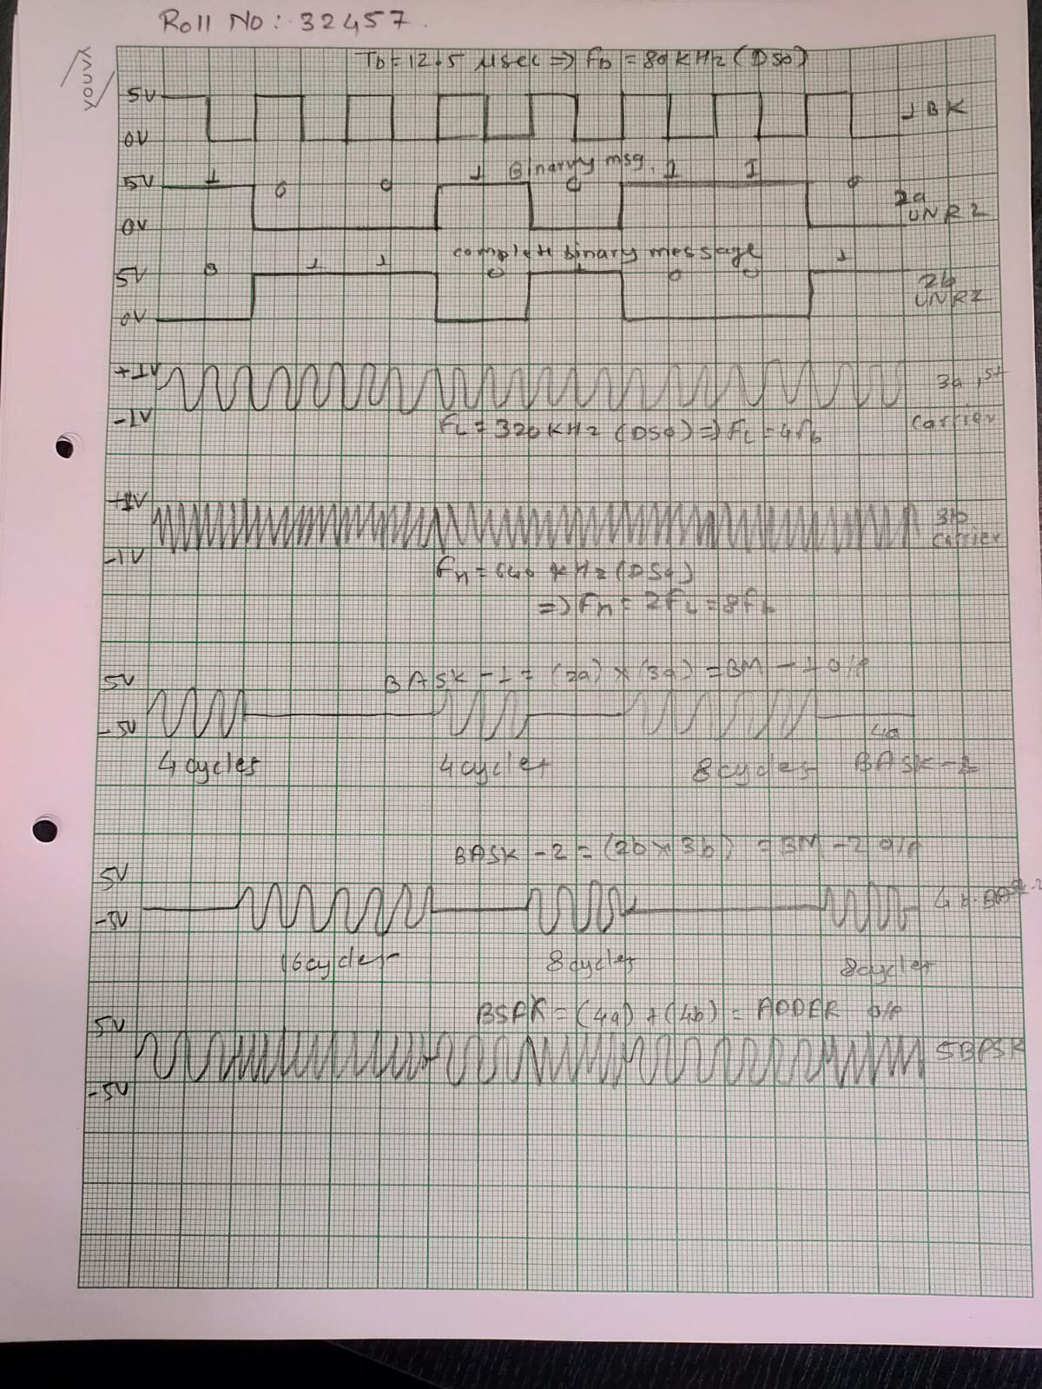

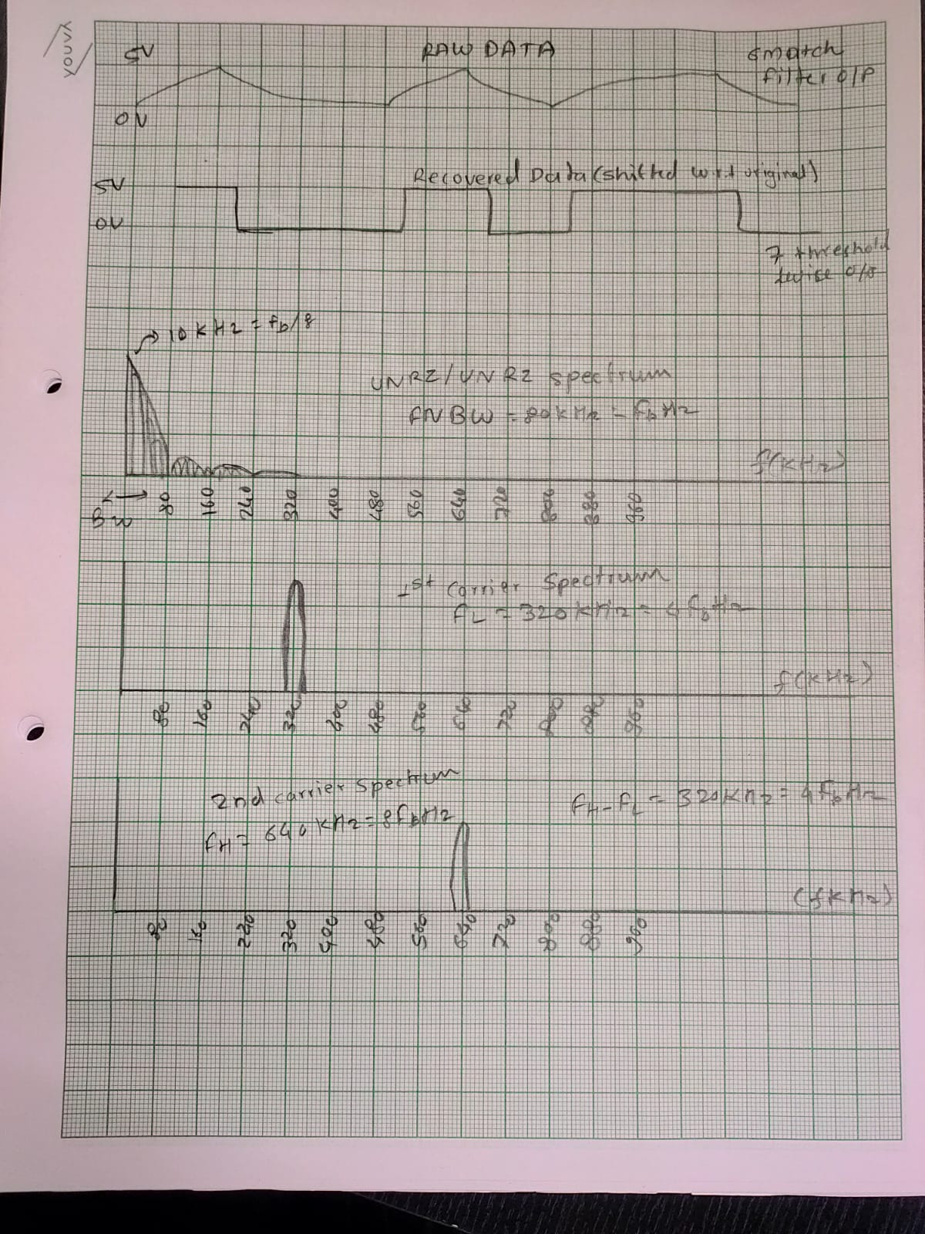

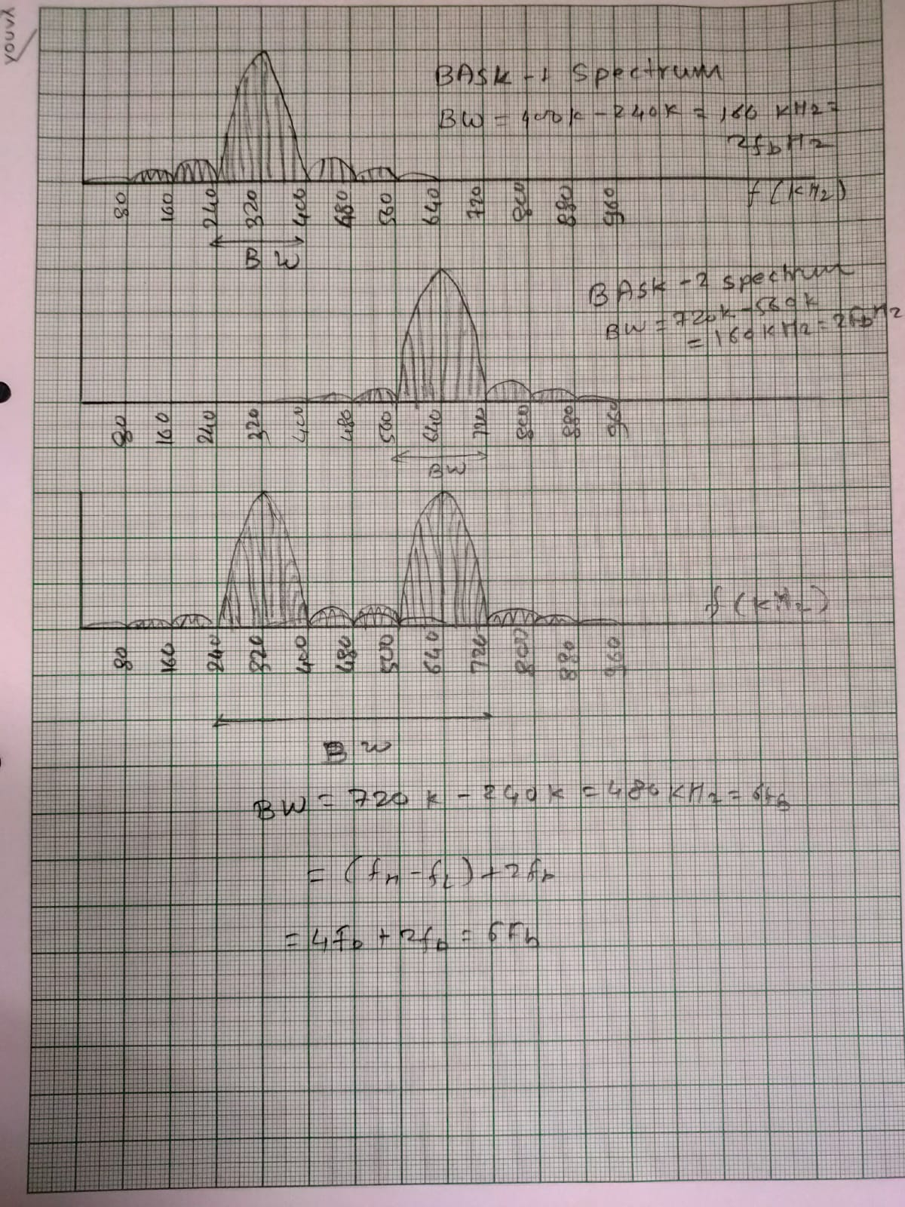

# CONCLUSION:

* In this practical we studied the blocks in BFSK transmitter and receiver.
* We studied the power spectrum of BFSK briefly.
* We studied difference between coherent and non coherent BFSK reception technique.

**RERFERENCES:**

* 1. Modern Digital & Analog communication system-B.P.Lathi
  2. “Communication Systems”- Carlson